**Markowitz** **portfolio optimization theory**

# The goal

The main purpose of the program is to assist individuals who are beginners in the field of investment by guiding them on how to allocate their money.

**How it works:** The program takes the total amount you want to invest and offers you two investment strategies:

1. **Minimum Risk Portfolio:** This strategy distributes your money across various companies in a way that minimizes risk while aiming for the highest possible return.
2. **Target Return Portfolio:** In this strategy, you input the desired return you wish to achieve, and the program allocates your money in a way that helps you reach — or potentially exceed — that target return.

# audience, stakeholder

Our current target audience consists of novice investors who are new to the investment field. The platform is intentionally designed to be intuitive and accessible, offering simplified user experience. Clear and concise instructions are provided to ensure that users of all backgrounds can easily navigate and utilize the program to make informed investment decisions.

# Methodology

We use Agile methodology, and it is a modern approach to project management, especially in software development. It emphasizes flexibility, collaboration, and customer satisfaction by delivering work in small, functional increments called "sprints". Unlike traditional methods, Agile allows requirements to evolve throughout the project, encouraging adaptive planning and continuous feedback. This iterative and incremental process enables teams to respond quickly to changes, ensure higher quality, and maintain continuous delivery. Common Agile frameworks include Scrum, Kanban, and Extreme Programming (XP), each promoting team collaboration, transparency, and continuous improvement. Agile has become a widely adopted methodology due to its ability to improve productivity and align products more closely with user needs.

# Requirements

* Functional Requirements:

A place to put the amount of money.

* Non-Functional Requirements:

System loads very fast.

* Business Requirements:

Smooth and simple UI for the user to make the user experience good.

* User Requirements:

Showing the Result of the portfolio after ending the processing.

* System Requirements:

Database or excel file contain the data using in the portfolio.

# Diagrams

Activity Diagram

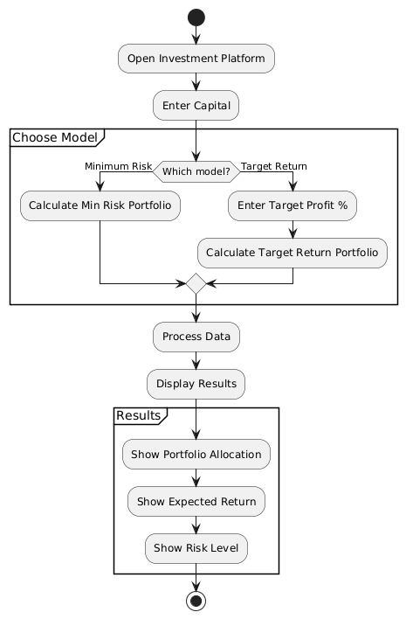

Class Diagram

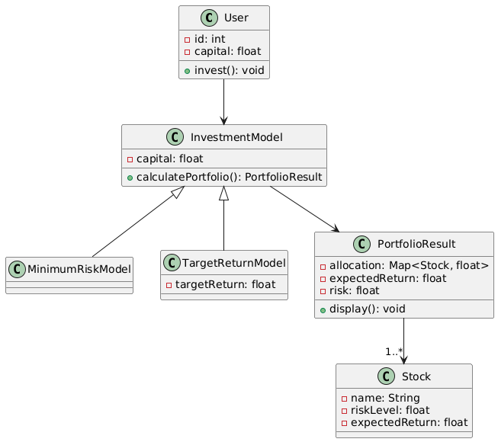

Sequence Diagram

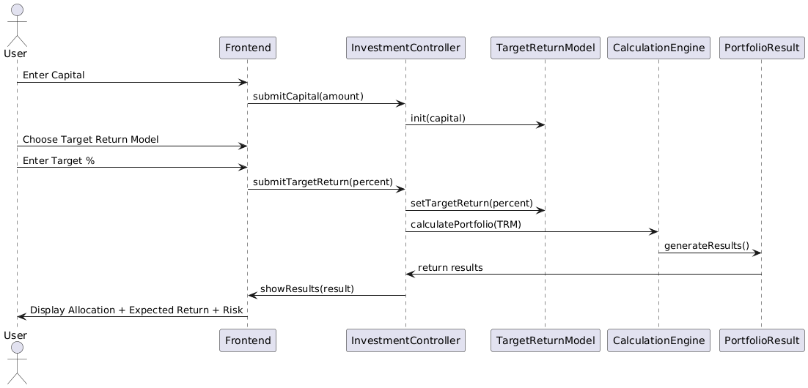

Use Case Diagram

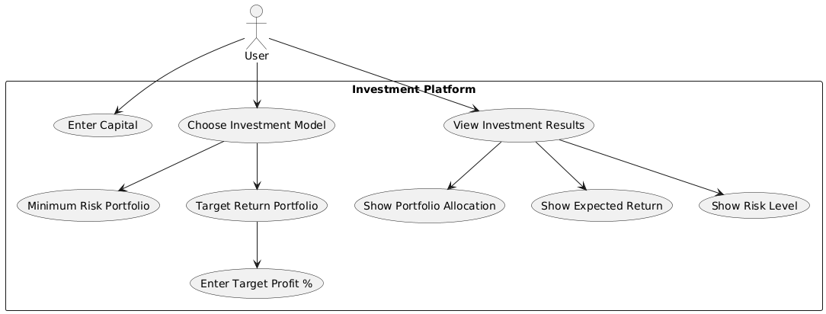

State Machine Diagram

